Welcome to

Villaveien Naturbarnehage SA

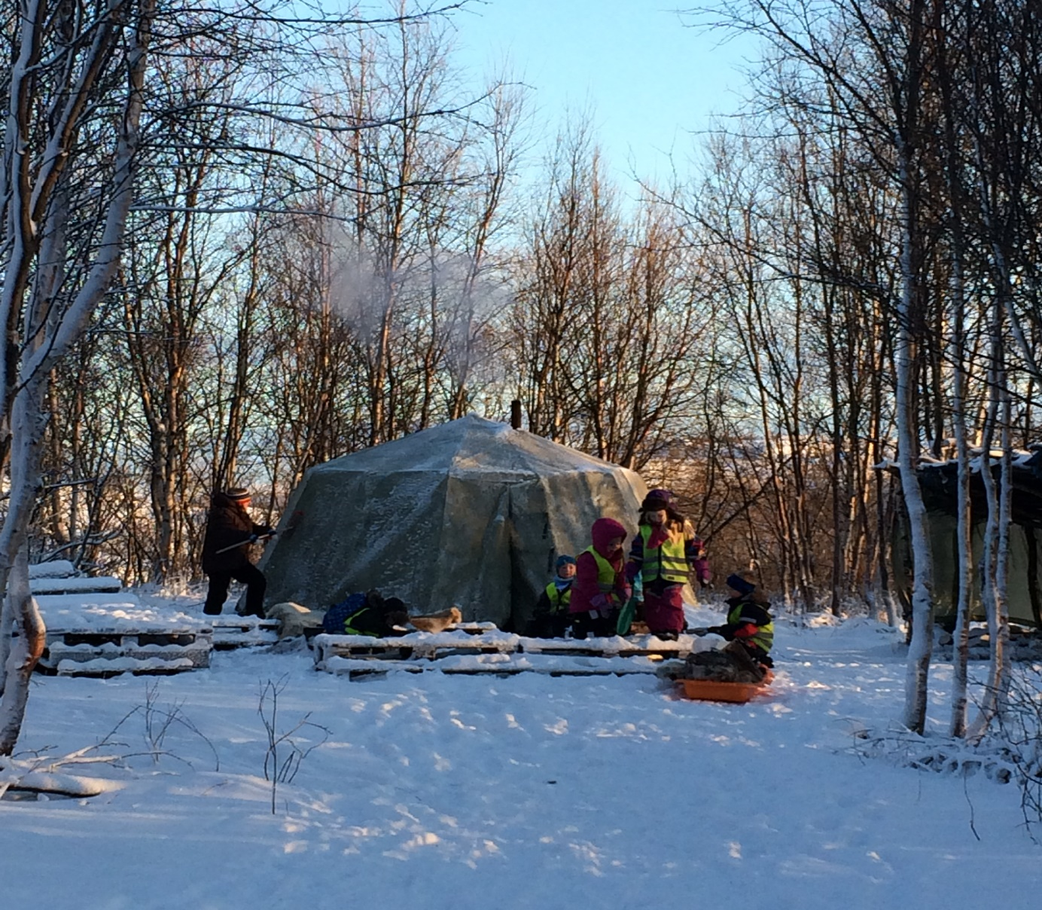

Backpacks on, let’s be gone! In Villaveien we take care of everyone!

Parents’ meeting and visiting the kindergarten
Good information provides a good start in the kindergarten.

You have now received an offer letter and have accepted a place at Villaveien Naturbarnehage SA. All of those offered a place in the main intake will receive a letter from the kindergarten with information concerning:
Start date
Primary contact
Kindergarten class
Visiting days in the kindergarten
Parents’ meeting for new parents
We wish to provide you with the best information possible and get to know you properly before you begin in the kindergarten.

«Getting to know you» period
«Getting to know you» period
During the first few weeks in the kindergarten, we spend time getting to know parents and children. The children will become familiar with the kindergarten’s physical environment, both indoors and outdoors, and get to know our daily rhythm and routines. They will meet a lot of other children and find new playmates. This is an exciting period; however, it can also be very tiring for the children. It is important that you have a calm home situation during this period and be available for the child and allow them plenty of time to process their new impressions.
Goals for the «Getting to know you» period:
Children and parents will get to know the adults and other children in the kindergarten.
Become confident and find new friends.
Become familiar with the indoor and outdoor areas of the kindergarten.
Get to know the daily rhythm and routines.
Children shall be happy in the kindergarten.
Children shall feel they master their new situation.
It is important that the “older children” are well prepared for the changes that will take place.

Methods:
Regular contact persons for new children
During the first few weeks, new children will have a regular contact person/primary person who will have additional responsibility for the well-being of the child. We do this to safeguard follow-up of the child during this hectic start-up phase. However, we would like to remind that many of our staff work in part-time positions. Therefore it is not possible for regular contact persons to follow up individual children every day. The child will in any case always be cared for by all of our staff.
Children that already attend the kindergarten will also be given the opportunity to show the new children round and help them become familiar.

Regular activities
During the first month we will maintain fixed routines. Getting to know the regular daily rhythm and activities makes the day predictable and inspires confidence in children.
The new children, during the initial period, will stay within the immediate kindergarten area so that they can become familiar there. After a time, they will take part in trips outside the area.
We will also have regular routines during communal storytime and other common activities, with focus on learning new names, with regular songs and stories.
We also arrange fun activities that provide positive experiences.
Parents’ meetings
New families to the kindergarten will be offered visiting days and a parents’ meeting during the month of June.
Parents’ meetings will also be held in September/October for all parents. At this meeting we discuss various themes. We welcome suggestions from parents regarding future themes and activities.

Practical information

Food
Children have all of their meals in the kindergarten. Breakfast starts at approx. 08.00. If the child is to eat breakfast in the kindergarten, they must arrive before 08.30.
A monthly charge is payable for meals which is added to the normal kindergarten fee. Please inform us if the child has any special food allergies.
Birthdays
Traditions around birthdays vary a little from department to department. The kindergarten buys and prepares sugar-free birthday food and juice is served. Speak to the staff in your department for further information.

Illness
In a kindergarten there is a high risk of infection as the children play so closely together. Therefore, if your child is ill, you must keep them at home. As a principal rule: If the child is to attend kindergarten, the child must be able to follow the normal daily kindergarten rhythm, including outdoor play. Please inform us before 09.00 if the child is not going to attend kindergarten!!
See separate information concerning children and illness.

Private toys
The kindergarten is not responsible for private toys. Please arrange with the kindergarten staff if private toys are to be brought to the kindergarten. Private bicycles must be parked outside of the gate for safety reasons, to safeguard the smaller children.

Nappies/diapers
If you have a child that uses nappies/diapers you must bring these to the kindergarten. Please do not bring the “Up and Go” type of nappy/diaper, as these are not very practical, particularly when out on trips outside the kindergarten. You will receive a text message if your child is running out of nappies/diapers.

Sleeping
Children that need to sleep during the day sleep outside in a pram. Please bring a pram, sleeping bag/quilt, harness and rain cover. It is especially important that you bring a “cat net” to prevent incidents where cats may jump into the pram. We have an outhouse in the kindergarten you can use if you wish to store the pram.
Remember to label all of your items.

Photography
With your permission, we take photographs in the kindergarten. These are hung as large posters and are used as educational documentation. When the child leaves the kindergarten, they are given a folder with photographs and other memories from their time spent with us.

Daily information
Each day, we will try to give you a brief summary of what the child has been doing during their day in the kindergarten. Occasionally, many parents arrive at the same time and it becomes a little difficult to provide full information to everyone. If you have any queries, please do not be afraid to ask. You may also experience that the information provided by the Infant department is somewhat different to that given by the departments for older children. This is because there is far more activity within the older children’s department and twice as many children to be followed up. The older children also wish to play more by themselves and it is therefore not always easy for the adults to observe everything that takes places during play. It is therefore important that parents listen to what their children say and to discuss any issues with kindergarten staff. If you as a parent feel that you do not receive adequate information, it is important that we receive feedback.
Be an active parent and ask us if you are concerned about anything! You can also contact us by telephone if you do not get the opportunity to speak to us in the kindergarten.
Monthly plan/monthly newsletter
Once a month we send out a monthly plan/monthly newsletter containing information about activities, projects, meetings, birthday celebrations etc. This is sent to all parents via email. The weekly plan is posted within each department.

Staff/parent meetings
Staff/parent meetings are arranged every autumn. During the spring term, parents wishing to schedule a staff/parent meeting can do so. A schedule list will be posted.
You can at any time (outside of these fixed meetings) request a staff/parent meeting. Contact the class teacher in the department.
All new parents are offered a start-up meeting.

Dropping off and picking up children from the kindergarten
Only parents/guardians are permitted to pick up children from the kindergarten. If another person is to pick up the child, the staff must be informed in advance. If other regular contact persons (grandparents, uncles/aunts) are to pick up the child without giving notice, these must be listed on the form.

Parking
Parking at the kindergarten is limited; however, it is normally sufficient during regular drop-off/pick-up situations. Please show consideration for pedestrians, switch off your engine and always close the gate to the kindergarten.

Guidelines concerning clothing at Villaveien Naturbarnehage.

Villaveien kindergarten has chosen to spend a lot of time outdoors, either within the kindergarten area or out on trips into the forest. With the following motto as a starting point: “Backpack on, let’s be gone! In Villaveien we take care of everyone!” we wish to provide good experiences outdoors. In order to achieve our goal of providing children with good experiences, appropriate clothing and equipment is important. We have created an overview of what children will need in order to stay warm and comfortable in the kindergarten.
THE INFORMATION FOCUSES ON AUTUMN, WINTER AND EARLY SPRING CLOTHING. IT IS DURING THESE PERIODS THAT IT IS MOST IMPORTANT TO HAVE THE CORRECT CLOTHING.

QUALITIES THAT CLOTHING SHOULD HAVE:
1. Base layers, autumn/winter/early spring. We recommend wool, a natural material. Having wool closest to the skin ensures a good warmth balance. Wool has excellent heat insulation qualities, as the curly wool fibres hold a lot of air. Wool provides heat insulation even when the clothing is wet - wool can absorb up to 30% moisture without feeling damp. At the same time wool regulates the temperature as it also insulates against heat. Wool also has several other sound qualities; it has good resistance to soiling, it retains its shape well whilst at the same time being flexible, allowing movement, and wool is fire resistant - it is the least flammable of all natural fibres.
We recommend footless tights instead of regular one-piece tights, as it is easier to change a pair of wool socks instead of a full set of tights.
2. Intermediate layers, autumn/winter/early spring. Intermediate layers should be of either wool or fleece. Fleece is better than wool for transporting moisture and in terms of drying time, whilst wool provides better insulation when wet. The set should be a two-piece, to make it easier to go to the toilet and we avoid having to undress the smaller children more than necessary when changing nappies/diapers outdoors.
3. Outer clothing: a winter suit should be soft and flexible to wear so that the child can move around freely. Waterproof and breathable suits are now available on the market; however, suits that are water resistant are also fine. The suit should have an elastic strap underneath the foot or a good snow lock. Avoid loose cords and fixed hoods as these can easily get caught. Ensure that the suit is wide enough around the wrists so that mittens can be worn underneath the suit. The hood should not be permanently sewn to the suit. All loose components that hang from the suit increase the risk of becoming caught on something. Ensure that the suit is long enough - suits that are too short quickly ride up above boots, these then become filled with snow/water.

Spring/summer/autumn suits Should also be waterproof or water resistant as well as windproof.
4. Rainwear. Two-piece rainwear, with high waist trousers is best. Then it is possible to just wear the rain trousers if it is wet outside. For smaller children it is often good to have a full suit. Remember that rainwear must not be too small and it must fit over an outdoor suit. There must always be an elastic strap on footwear. A rain suit should also be made of soft material.

5. Mittens. Try to find mittens that allow the child to hold items during play. Thick polar mittens make play difficult, and often results in the child removing the mittens. Thin polar mittens are not as warm; however, they allow the child to play normally. Polar mittens should have a long gauntlet and be wide enough to pull easily over the suit. Woollen mittens, with thumbs, are also recommended.
On certain days, only rainproof mittens are suitable. It is possible to purchase rainproof mittens with a thin lining, or it is possible to wear a pair of woollen mittens inside them.

Finger gloves are not recommended for outdoor play as these are often cold and wear out very quickly. However, older children within the infant department can have a pair of these in the kindergarten and children in the older children department have a pair of finger gloves in the top pocket of their backpacks. This type of finger glove is convenient when eating outdoors. Thin woollen mittens are a good alternative.

6. Hats and scarves. Hats must be appropriate for the season, and protect the ears. One tip is to blow into the hat before purchasing it to see how much it protects against wind. It is also possible to purchase windproof hats.
We recommend a snood instead of a scarf. Scarves should be avoided due to the risk of becoming caught on objects.

7. Shoes/boots/sandals/winter footwear. Different seasons and weather require differing footwear.
Winter footwear. Children attending kindergarten need good winter footwear. The qualities to look out for are: that they are waterproof, breathable and have good insulating qualities. It is also important to make sure that the footwear goes above the ankle. One tip is to buy shoes that are slightly too large so that it is possible to use woollen insoles in the shoes.
Cherrox. Cherrox are good to have in the kindergarten for wet days when it is cold outside. Cherrox is a brand of thermal boot made from PVC, i.e. wellingtons. This material is not breathable and so can lead to damp and clammy feet, which in turn make it easy to get cold feet. However, they are a good alternative on very wet days. Cherrox are not recommended for use in temperatures lower than -5°C.

Wellingtons can be made of rubber or PVC (synthetic material). Wellingtons that are made of rubber are the most expensive, but are also the strongest. Wellingtons made from PVC are the cheapest type.

Sandals and slippers. Sandals can be an alternative to slippers in the kindergarten. The advantage of sandals is that the child does not feel clammy in them and they are a better fit.
8. Other:
Sun cream can be required throughout the year. Apply sun cream before the child comes to the kindergarten, we add an extra layer during the morning/afternoon.
Sunglasses are a good idea to have in the kindergarten. Even if the sun is not shining, the light can be very bright during the winter months.
Skis in the kindergarten: Children over 2 years old can bring skis to the kindergarten. Ski poles are not necessary before the child is able to use them properly. Before this they are simply in the way. We do not recommend the use of ski poles within the kindergarten area. Children over 3 years old must have a separate backpack in the kindergarten which is suitable for taking on trips. This backpack is used when the child is out on a trip, to carry extra mittens and similar. It should have a chest strap so that it sits well on the shoulders and does not slide down. The backpack must not be too heavy, i.e. maximum 10% of the child’s weight.
Children must have an empty drinking bottle in the backpack. This is filled with water before we set out on a trip.

9. Change of clothing. There must be a minimum of 2 full changes of clothing in the child’s clothing basket at any time. The kindergarten does not have a lot of drying space, so that there must be enough clothing for a couple of changes. Check the basket a minimum of once a week, and keep an eye on the items we send home. Here is an overview of the type of clothing that should be in the basket and hanging in the changing room:

AUTUMN/WINTER | SPRING/SUMMER
Wool underwear  Wool jumper/fleece  Wool tights/fleece  Wool socks  Socks  Hats  Snood  Mittens  Sweat suit  Woollen footless tights  Trousers  Jumper  Slippers/indoor shoes  Rainwear (soft)  Suit  boots (with wool insoles)  Cherrox  Winter footwear (with wool insoles) | Sweat suit  Underwear  Windproof jacket  Socks  Shorts  T-shirts  Sun hat  Good outdoor sandals that fit well  Training shoes  Outdoor play suit  Rainwear  Boots

10. Labelling of clothing and other equipment
Put simply, everything that the child has with them in the kindergarten must be labelled. When we are in the changing room with 20 pairs of ski boots and only 5 of them are labelled, a lot of unnecessary time goes in finding the correct boots, time that could be spent outdoors on a trip. Use the enclosed order form to purchase name labels or purchase a permanent marker pen and write the child’s initials/name on the name labels in clothing.
We hope we have provided some tips on clothing in the kindergarten. The enjoyment of spending time outdoors begins with correct and appropriate clothing. If you have any queries, please ask the kindergarten staff.

We are looking forward to getting to know you and we hope you will enjoy being with us in the kindergarten!
Sincerely, Villaveien kindergarten staff.

outdoor trip areas at Villaveien

